37.16: 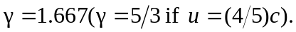 a) In Mavis’s frame the event “light on” has space-time coordinates 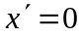 and 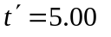s, so from the result of Exercise 37.14 or
Example 37.7, 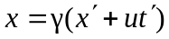and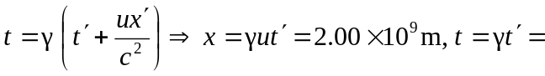
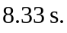
b) The 5.00-s interval in Mavis’s frame is the proper time 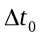 in Eq. (37.6), so 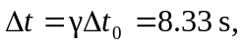as in part (a).
c) 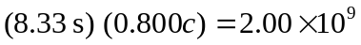 m, which is the distance found in part (a).

